So you just cloned the repo from bitbucket in a dir say wks.

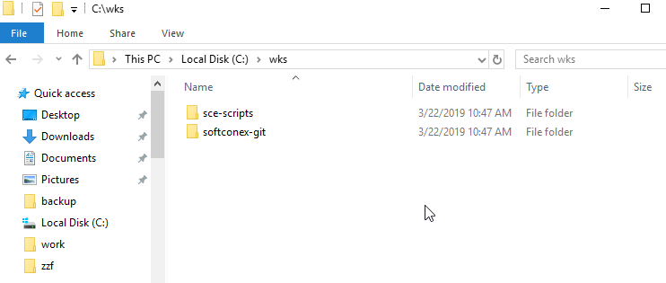

Open Intellij and do a import project

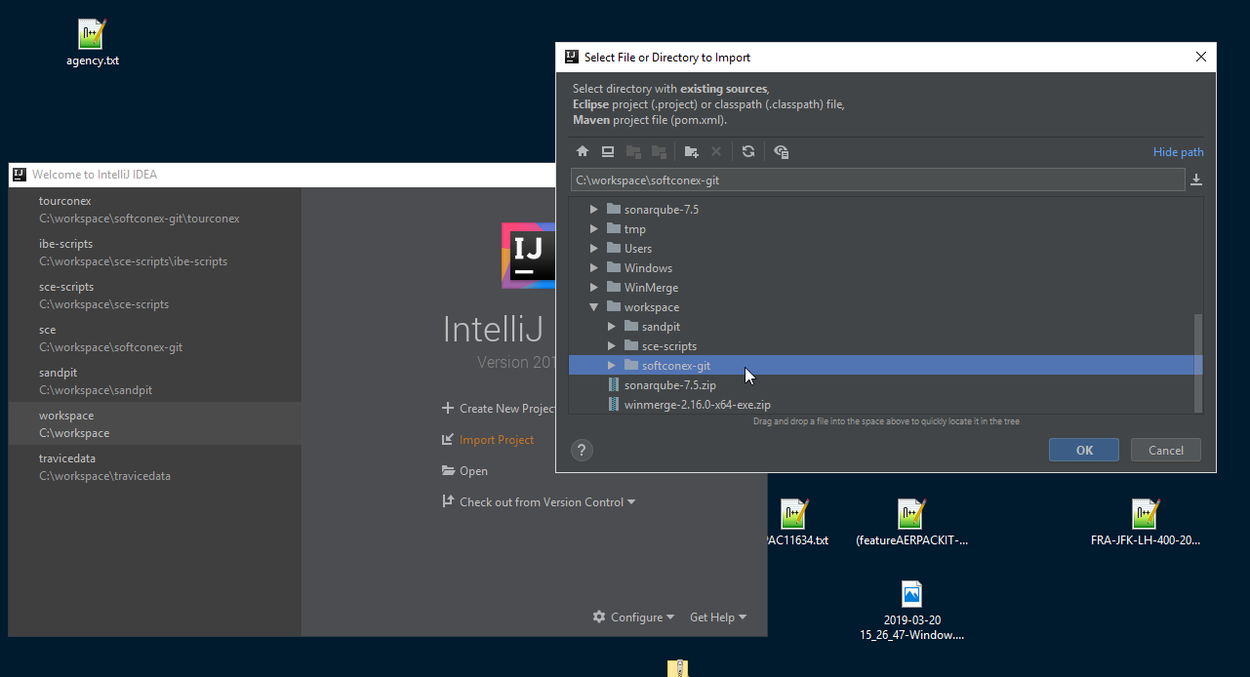

Select Maven as we have maven projects

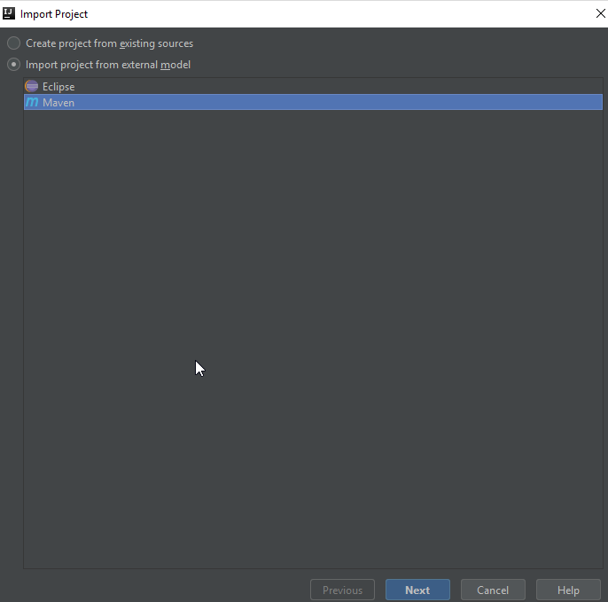

Now Make sure to check the 1 and 2 and uncheck 3

- Search for projects recursively
- Create module groups for multi-module Maven projects
- Create IntelliJ IDEA modules for aggregator projects (with 'pom' packaging)

Use the Project Structure to check you have all modules

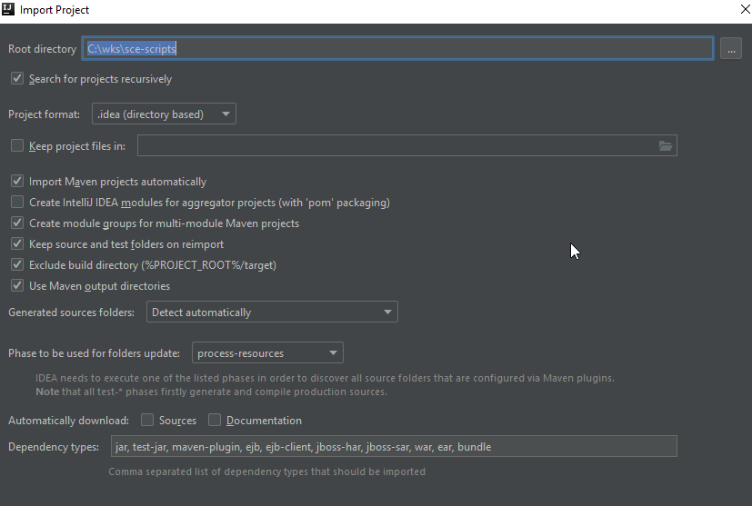

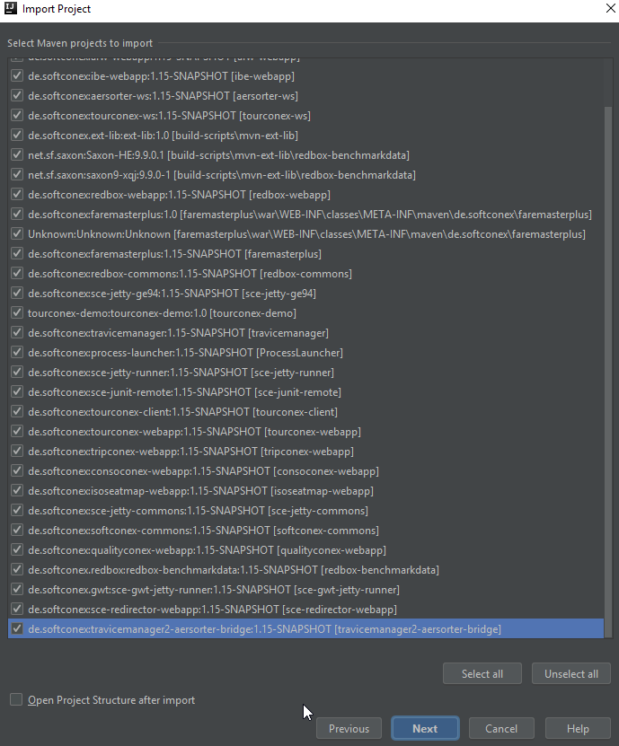

This is with the Create module groups for multi-module Maven projects NOT enabled i.e. No goupings

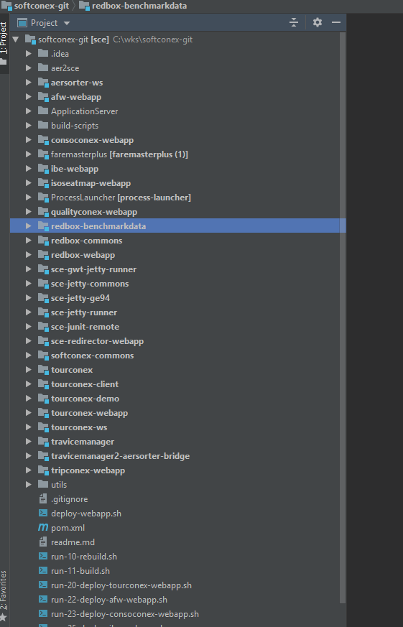

This is with the Create module groups for multi-module Maven projects enabled

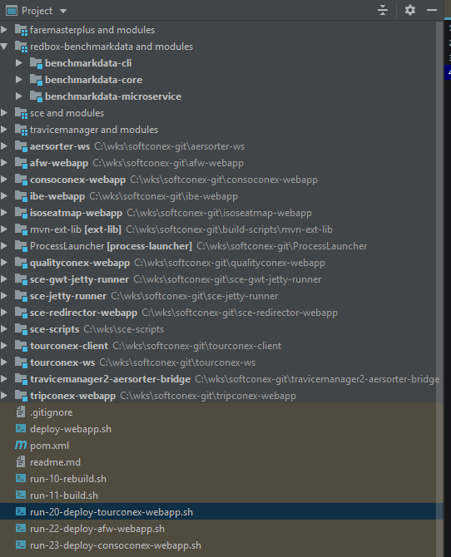

If needed you can remove modules ( this will NOT delete any files ) also can be done in Project Structure or from the maven tab on the right

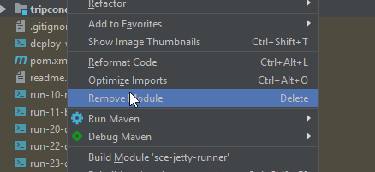

Remove Project from maven tab

